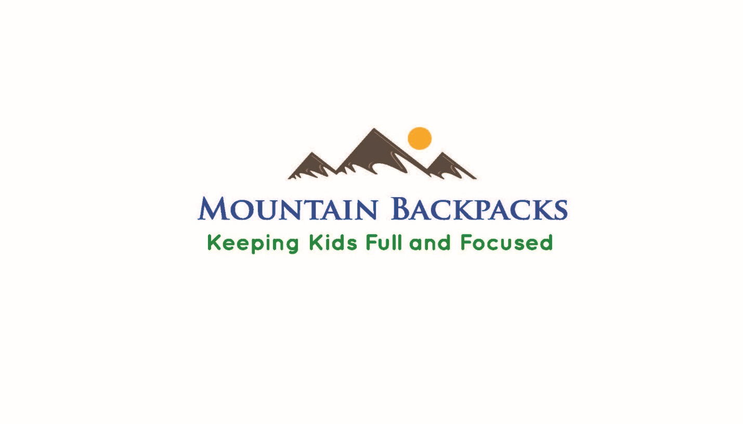
Mountain Backpack Enrollment
2018-2019

Mountain Backpacks is a supplemental food program whose mission is to help students stay full and focused. Each Friday your child will take home a backpack filled with breakfast, lunch and snacks for the weekend. Your child returns the bag to the school on Mondays and we fill it back up throughout the school year! Fill, eat, and repeat, it’s that simple. There are no qualifications to enroll and only contact information is requested. To help over extended school breaks families have the option of taking home grocery boxes and holiday meals. Fill out the form below and return it to your school office or email shelleyharmon89@gmail.com. If you have younger/older children in the home and would like them to receive a backpack also please list their name and ages below. You may use the program full time or on an as needed basis. If you have further questions call Shelley Harmon at 303-653-2732.

Child’s Name School/Grade/Age Food Allergy?

___________________________________________________________________________________

___________________________________________________________________________________

___________________________________________________________________________________

___________________________________________________________________________________

Name of Parent/Guardian Cell/Home Phone # Email Address

___________________________________________________________________________________

___________________________________________________________________________________

Circle your preferred method of communication: PHONE TEXT EMAIL

To keep updated on the program and for more information visit our website at www.mountainbackpacks.org and our Facebook page Mountain Backpack Program

